Adrien Protzel

S -> ABC | aAA

A -> AAC | C | b

B -> BB | a | λ

C -> CD | b

D -> Da | abD

Remove λ

S -> ABC | aAA | AC

A -> AAC | C

B -> BB | a

C -> CD | b

D -> Da | abD

Fix unit productions

S -> ABC | aAA | AC

A -> AAC | C | b

B -> BB | a

C -> CD | b

D -> Da | abD

Fix non-terminals

S -> HC | EG | AC

A -> GC | CD | b

B -> BB | a

C -> CD | b

D -> DE | ID

E -> a

F -> b

G -> AA

H -> AB

I -> EF

1. W1 = 1 0 1 1 3 = not in L(G)

| i/j | 1 | 2 | 3 | 4 | 5 |
| --- | --- | --- | --- | --- | --- |
| 1 | B | S | B | Ø | Ø | Ø |
| 2 |  | A | Ø | Ø | Ø |
| 3 |  |  | B | Ø | Ø |
| 4 |  |  |  | B | Ø |
| 5 |  |  |  |  | D |

W2 = 0 0 0 1 2 = in L(G)

| i/j | 1 | 2 | 3 | 4 | 5 |
| --- | --- | --- | --- | --- | --- |
| 1 | A | A | A | S | B | S | B |
| 2 |  | A | A | S | B | S | B |
| 3 |  |  | A | S | B | S | B |
| 4 |  |  |  | B | B |
| 5 |  |  |  |  | C |

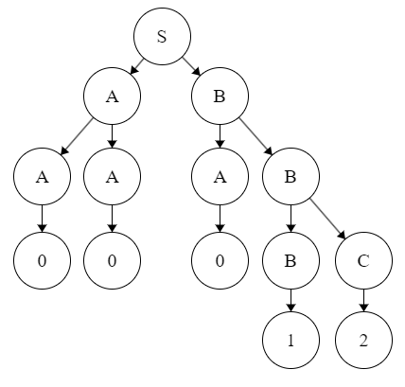

1. 1. Push aaa for each a. Then pop an a for each b. So for each a there are 3n a’s and then 2n a’s are popped for each 2n b. The stack is accepted if the final string is Z.
   2. Push 2 b’s per b and only 1 a per 2 a’s. Make the stack only a’s or b’s depending on first input.

